The time hath come to experience the elegant, articulate voice of Mumia Abu Jamal, and to experience the glories of the actualized struggle!

On October 12th, 2000, 12:30 University Center Room 239, there will be a presentation of Mumia Abu Jamal’s CD All Things Censored and discussion afterwards.
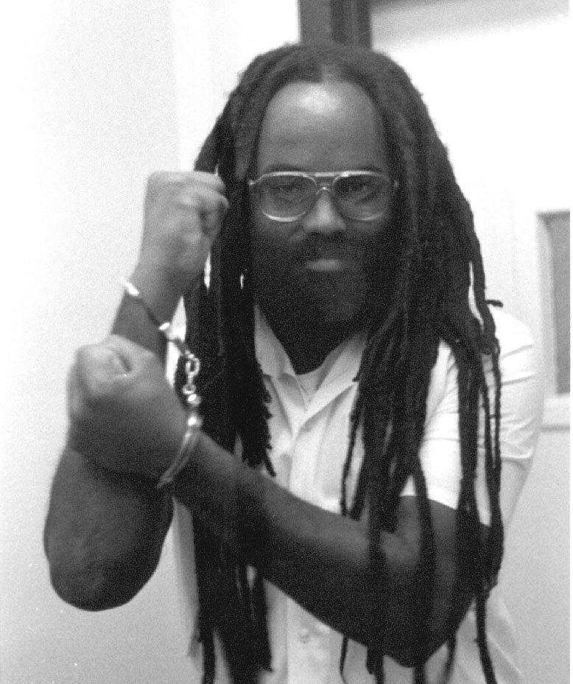
Be there!

Sponsored by Federation Without Television

