Mumia Abu Jamal Awareness Week
April 1-8, 2000.
Rally for a cause! 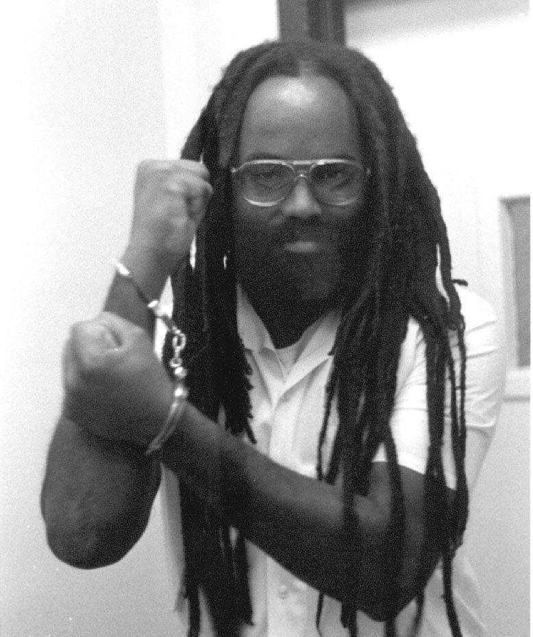
Participate in a jam-packed week!
This week we are going to do many things to spark consciousness and to fight the injustice of Mumia Abu Jamal's plight.

We are going to put on events which promote awareness of Mumia Abu Jamal and all the issues of his case.

- Sunday April 2nd, 8:00 p.m.: Chalking and Presentation of Mumia’s case and discussion. Nelson Hall room 308.

- Monday April 3rd, 6:30 p.m.: Mumia Abu Jamal/Revolutionary Poetry Reading. Nelson Hall room 308.

- Tuesday April 4th, 6:30 p.m.: Reading of Mumia Abu Jamal’s columns and discussion. Nelson Hall room 308.

- Wednesday April 5th, 12:00 p.m.: Discussion: “How to Commence the Revolution”. Nelson Hall room 308.

- Thursday April 6th, 8:00 p.m.: Anti-Death Penalty Rally. Nelson Hall room 308.

- Friday April 7th, 12:00 p.m.: Painting For Mumia Day. Nelson Hall room 308.

For more information:

Please call Andrew Bushard
@341-5750 or email fedwittel@uwsp.edu

Sponsored by Federation Without Television

