A Crucial Event!
We are railing for total justice for Mumia Abu Jamal

The National Day of Art to Stop the Execution of Mumia Abu Jamal: Mumia 911

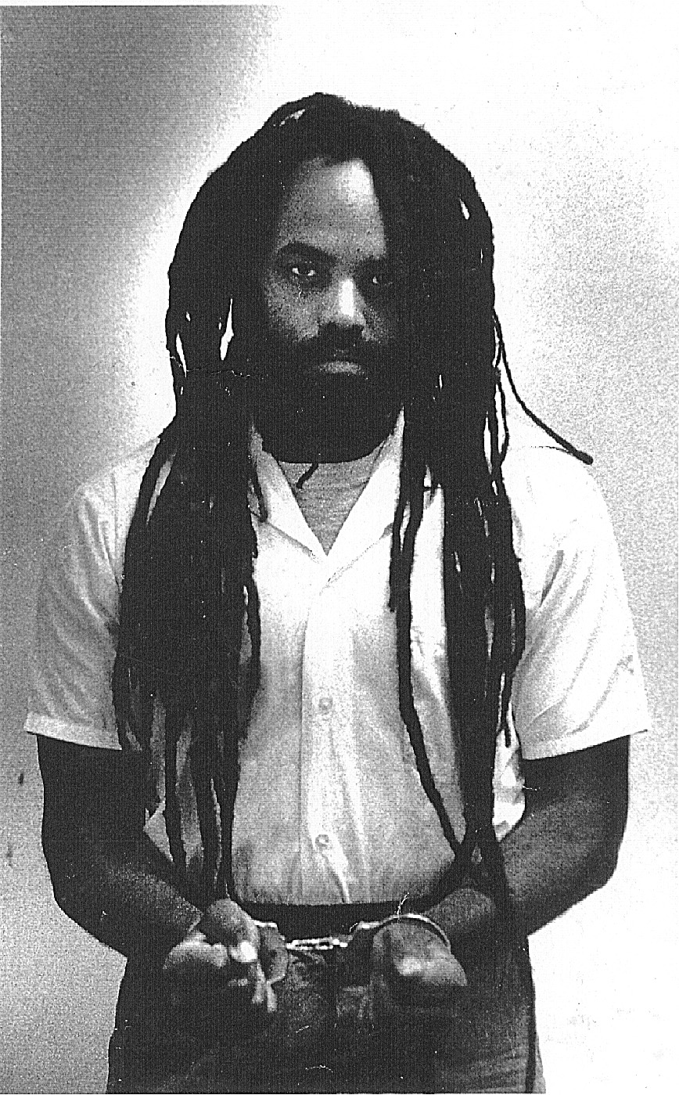
On this day, we are eloquently denouncing the injustice of Mumia Abu Jamal's plight, we are passionately
proclaiming our desire to free this contemporary freedom fighter

We will utilize art to rally in support of a noble man

On September 11, 1999 @ 7:30 in the U.C. Anderson room, we will be making a beautiful banner for Justice for Mumia week, having dancing and any musical instrument playing, and a reading of original revolutionary poetry

Please bring any art supplies, original revolutionary poetry and musical instruments!

Information: call Andrew Bushard @341-5750
or email fedwittel@uwsp.edu

Sponsored by Federation Without Television

