Public Lecture:
“The Frightening Soulful Dangers of Gambling”

On Halloween Night

Scary, petrifying and sad.

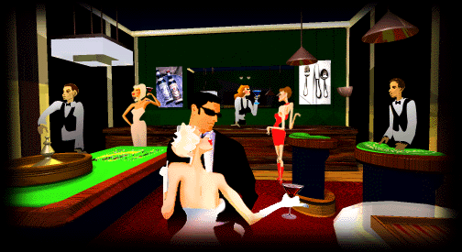
Wednesday October 31st 5:00 p.m., University of Wisconsin Stevens Point University Center Room 207.

Sponsored by Federation Without Television

