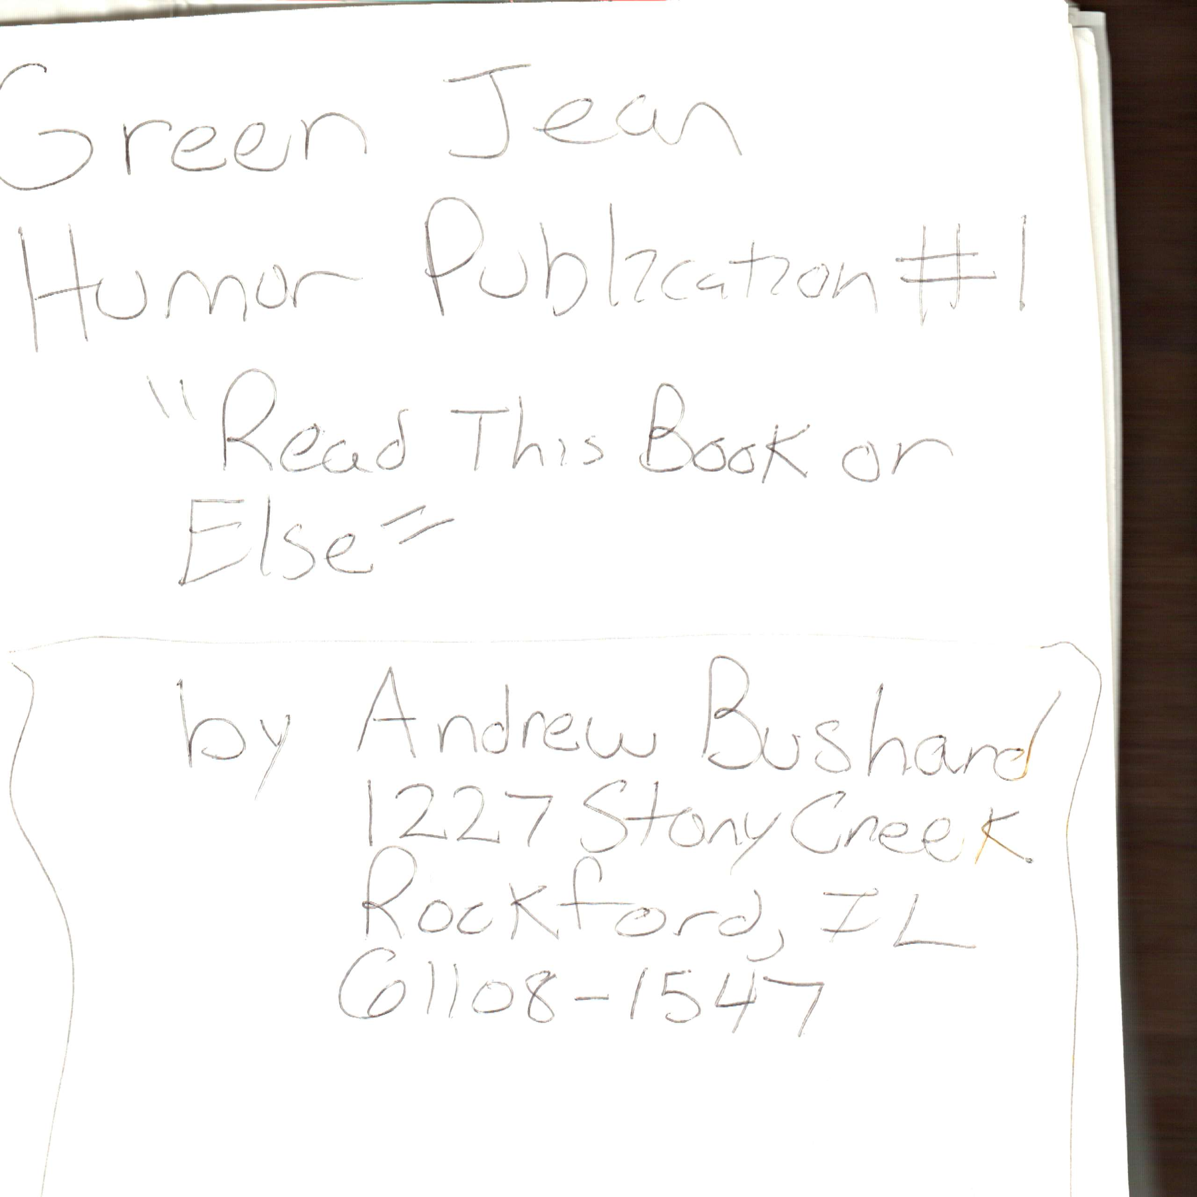

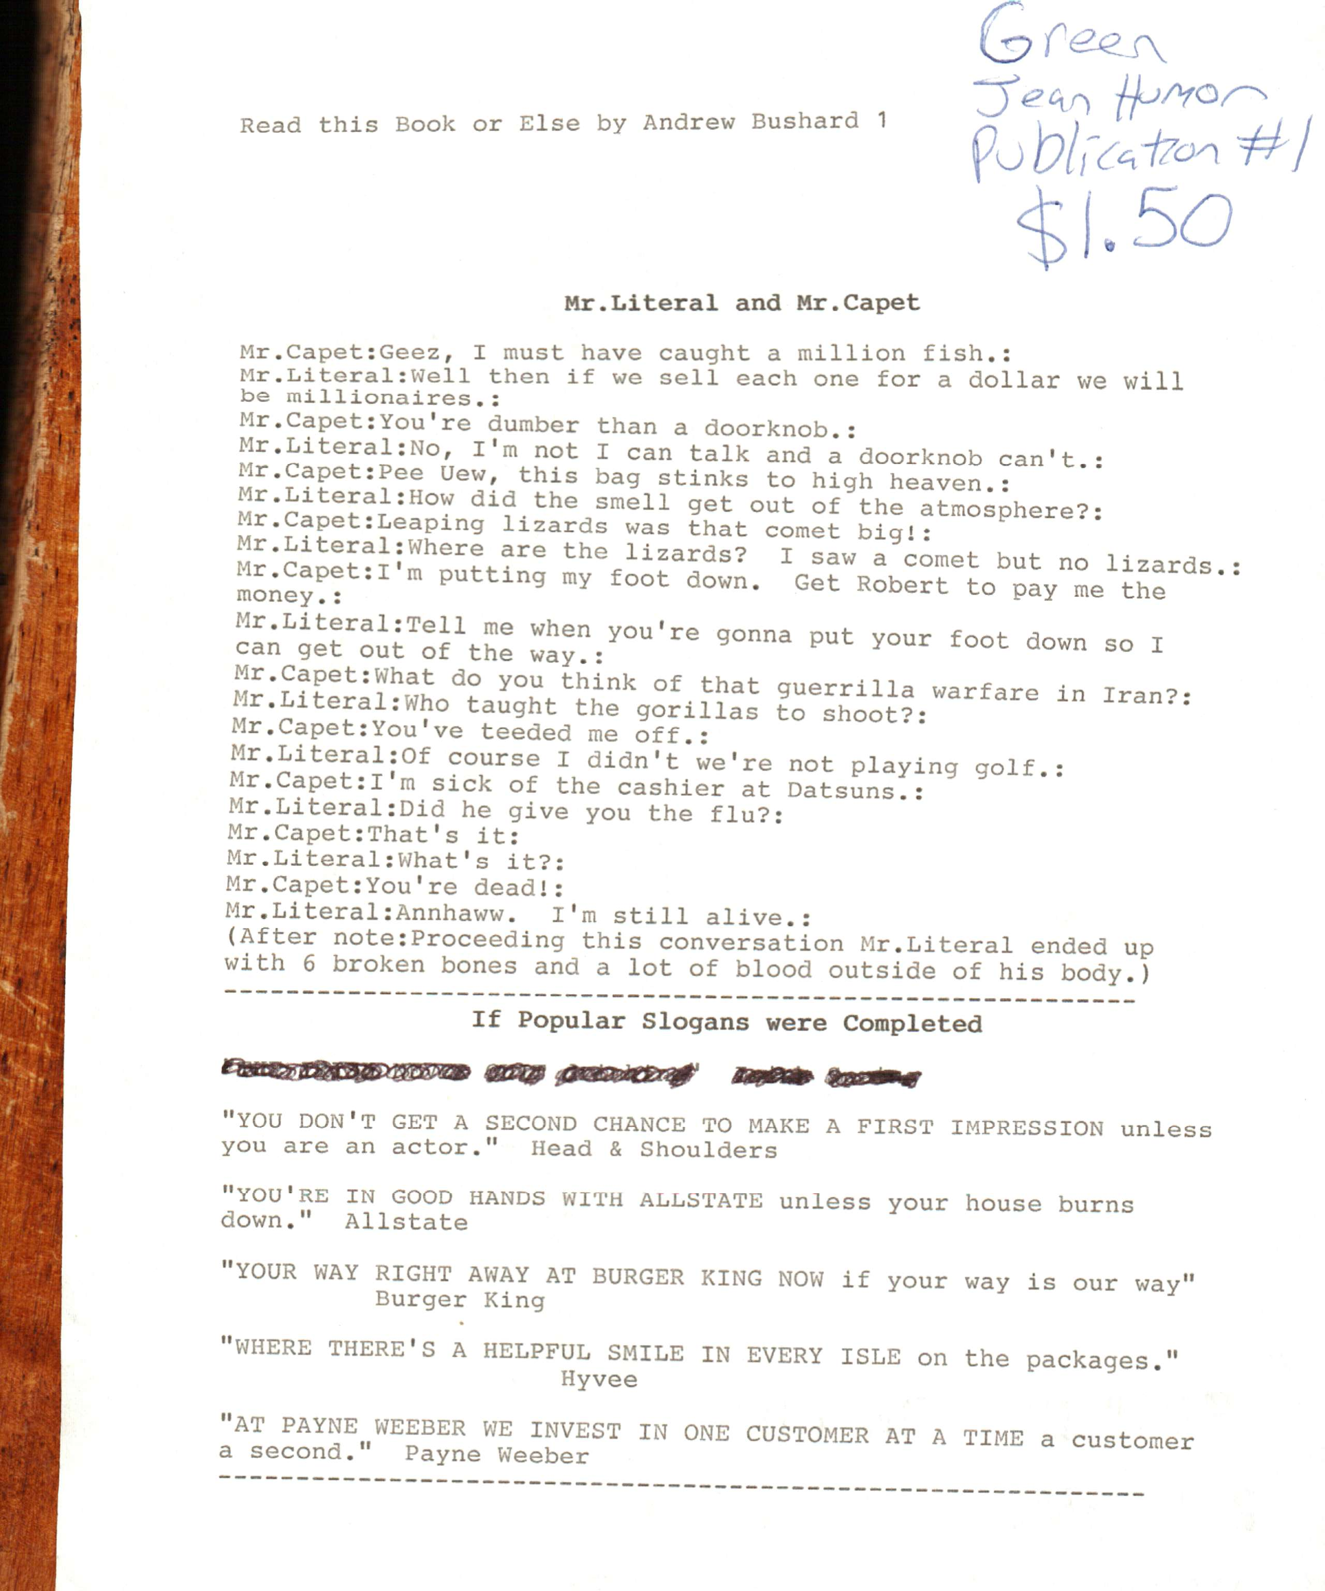

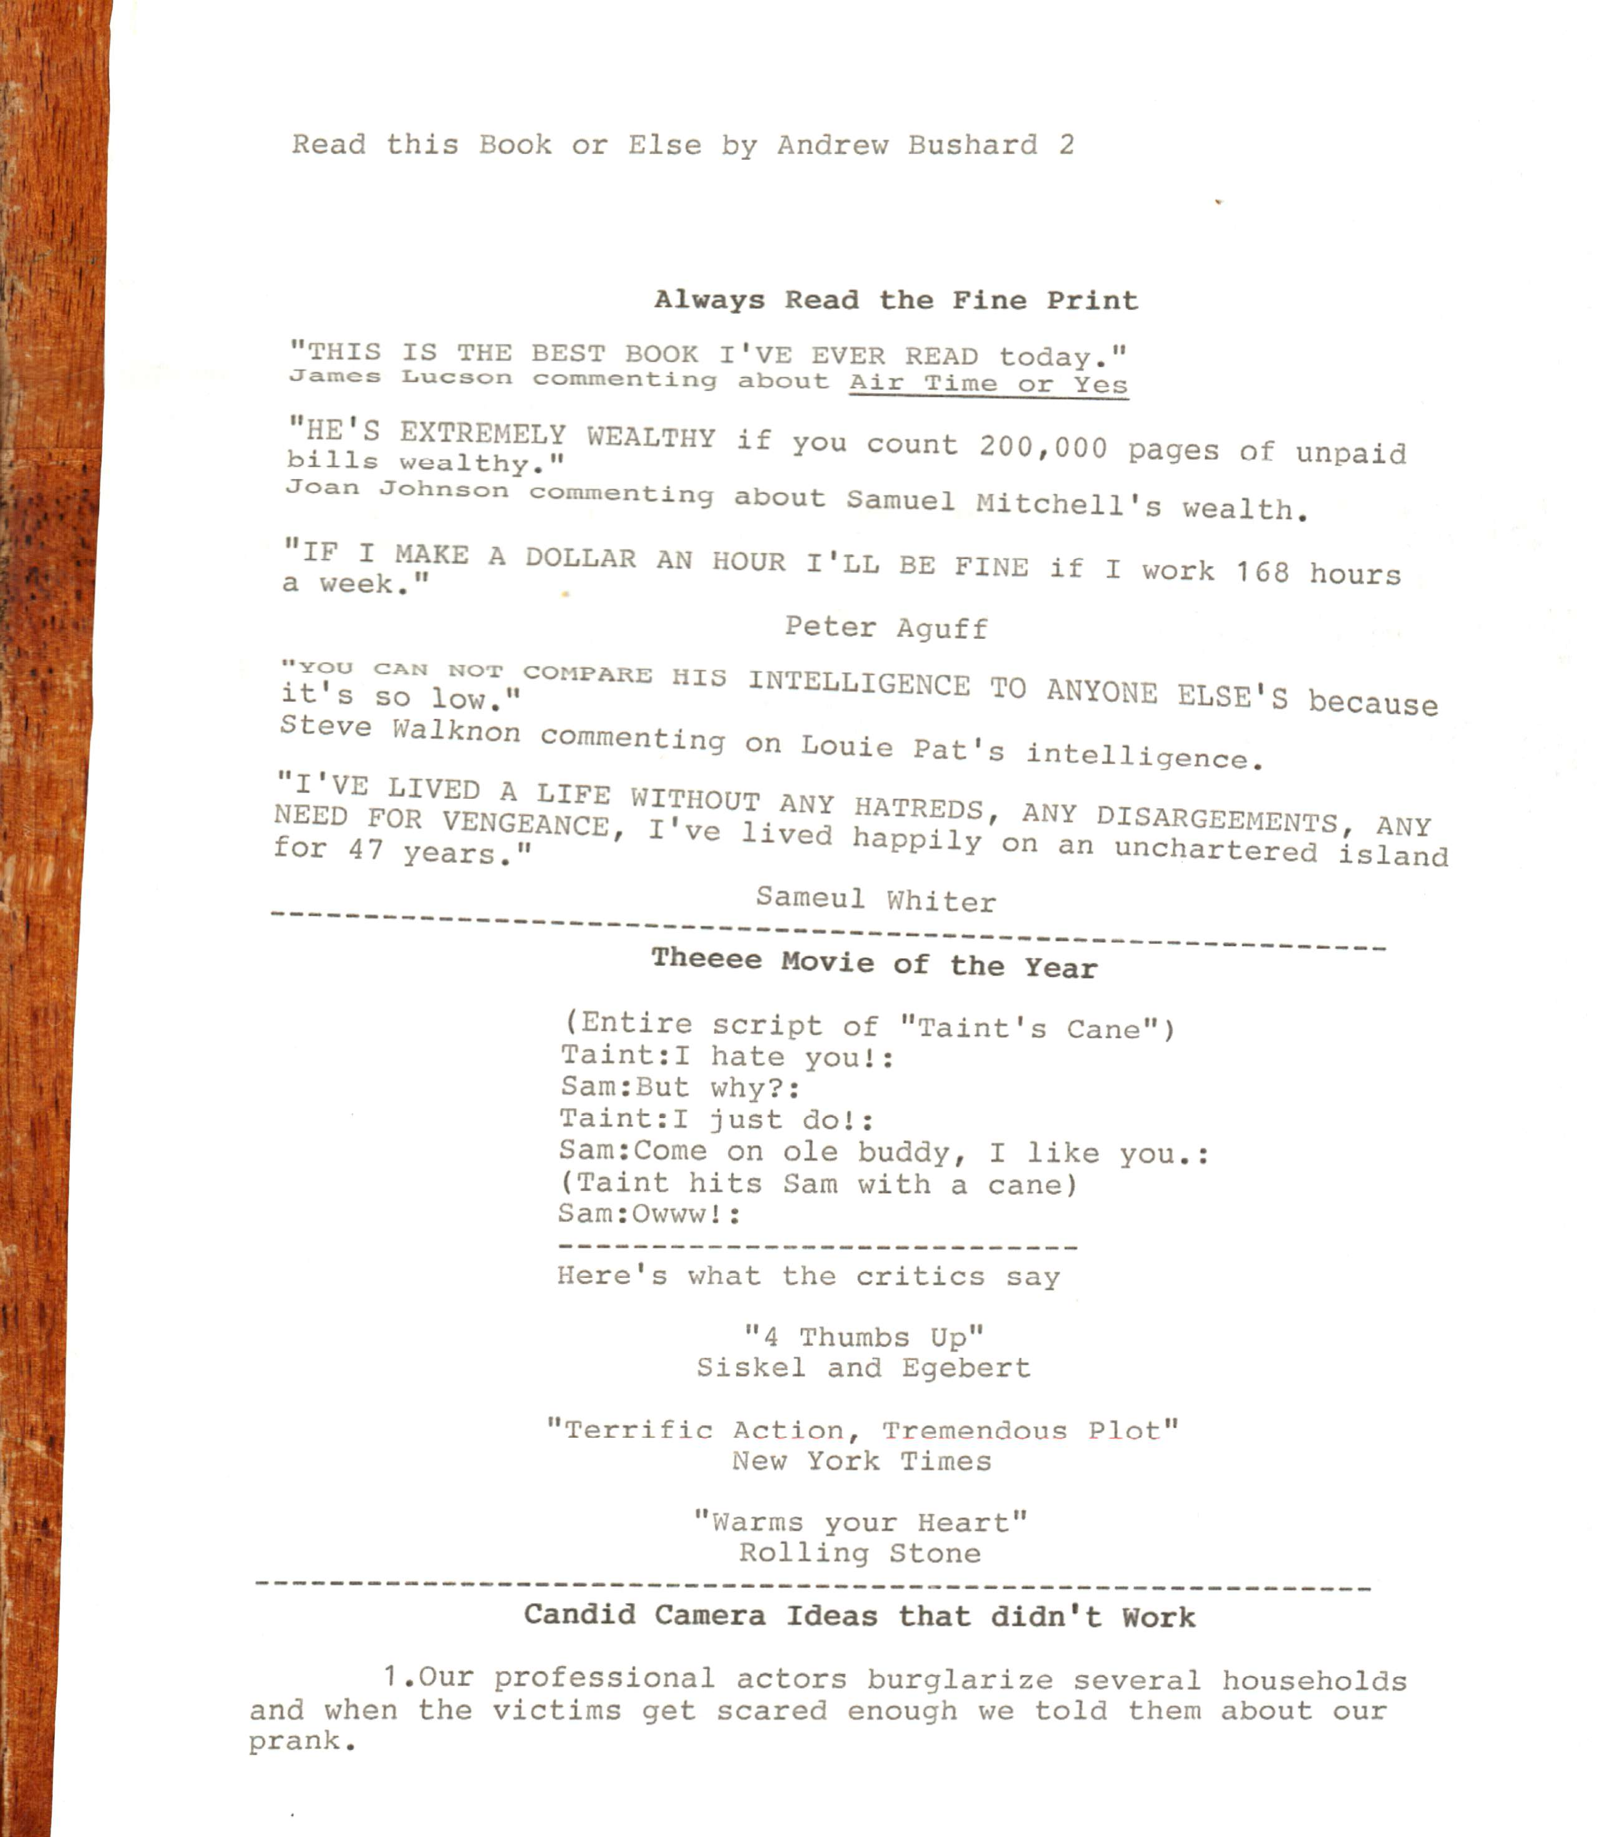

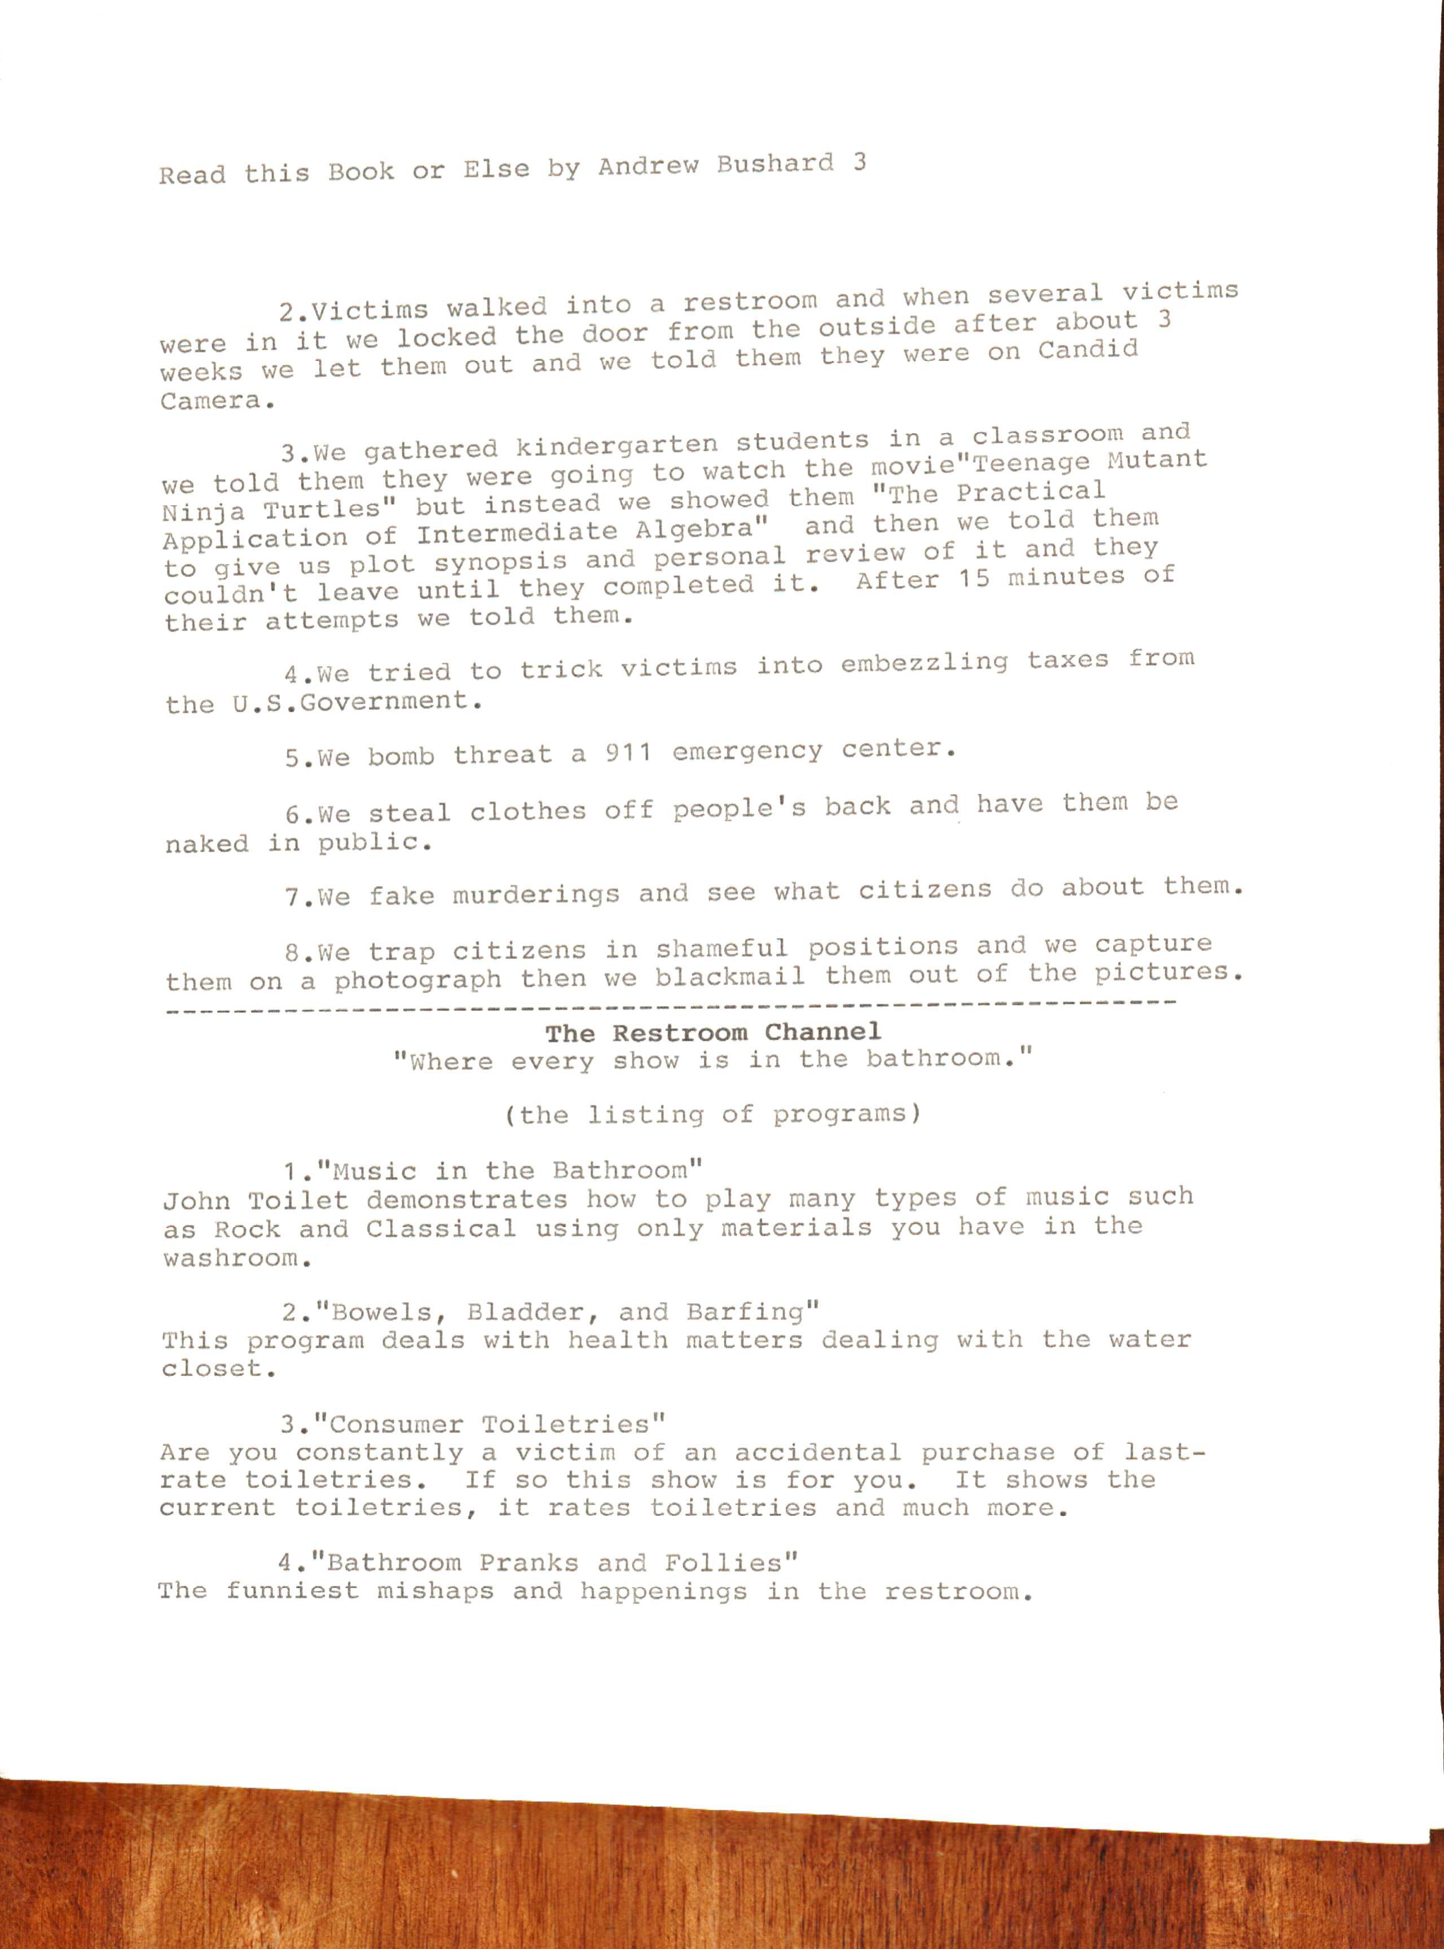
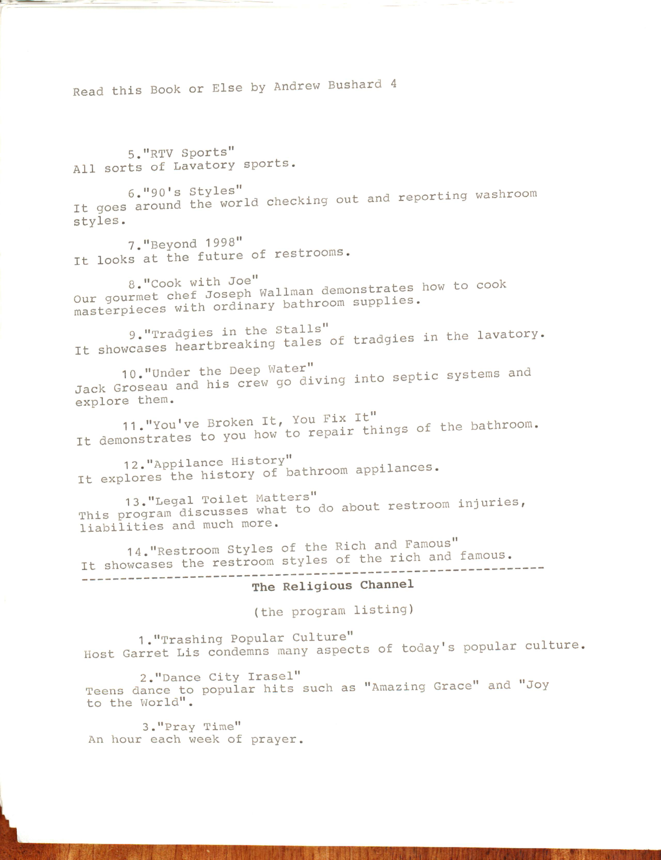

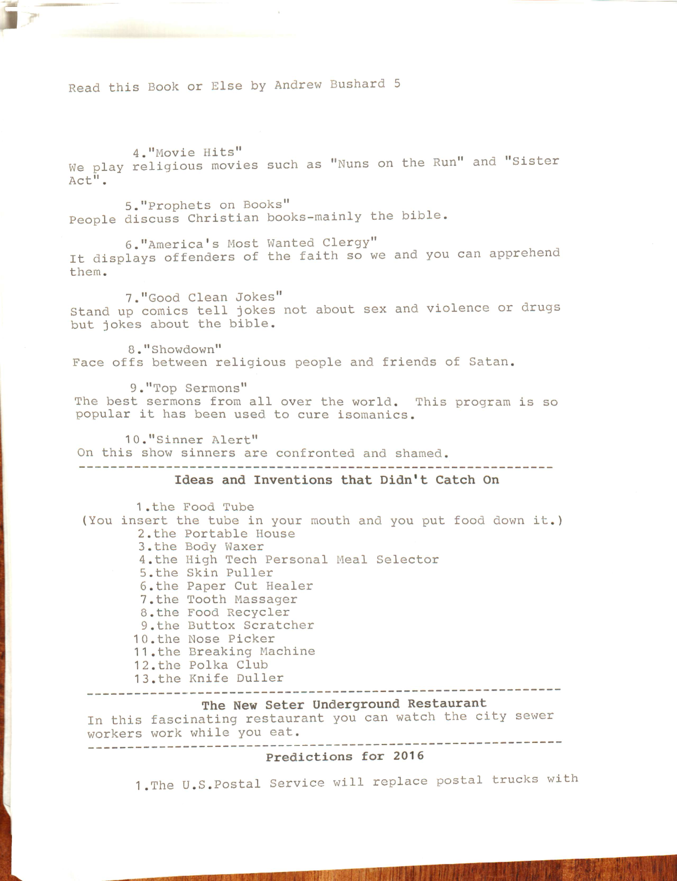

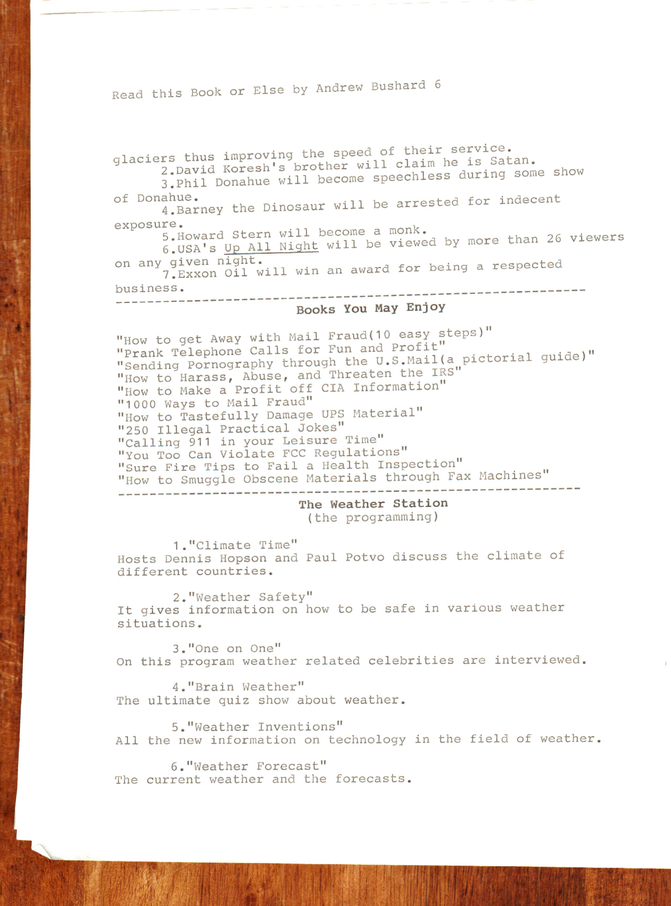
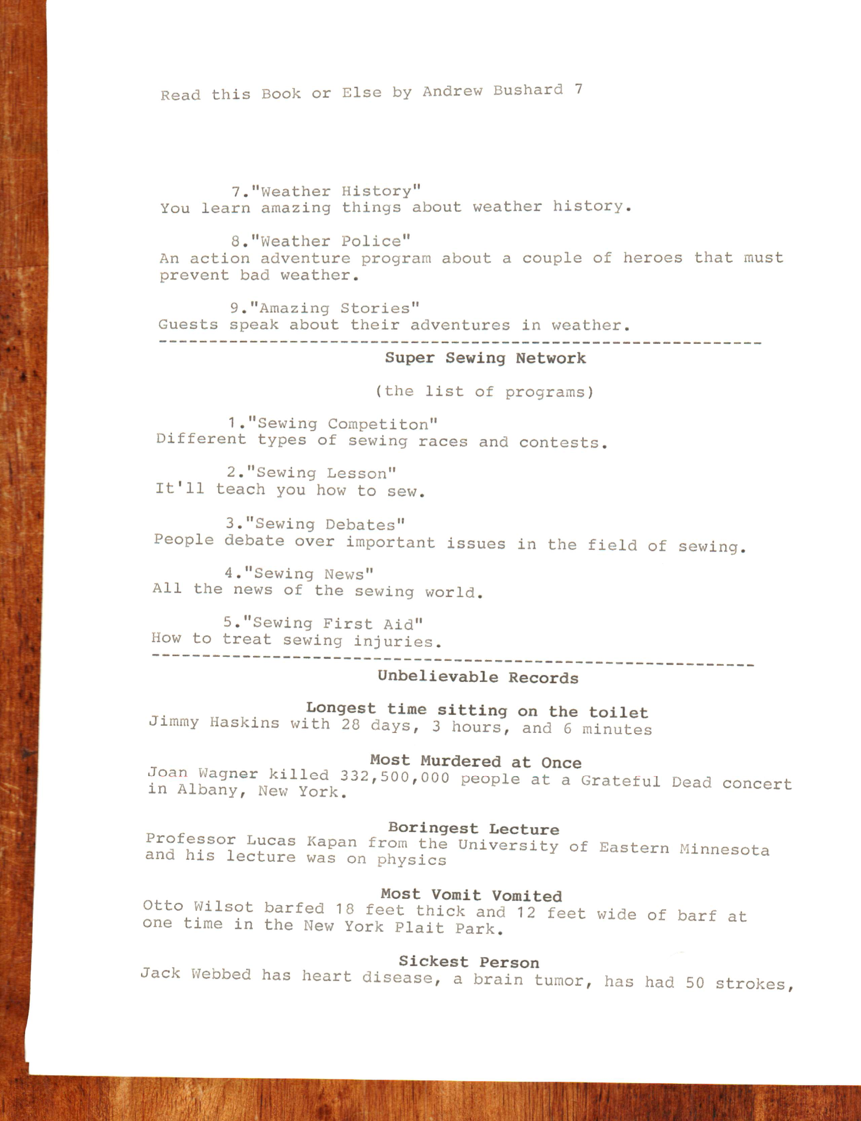

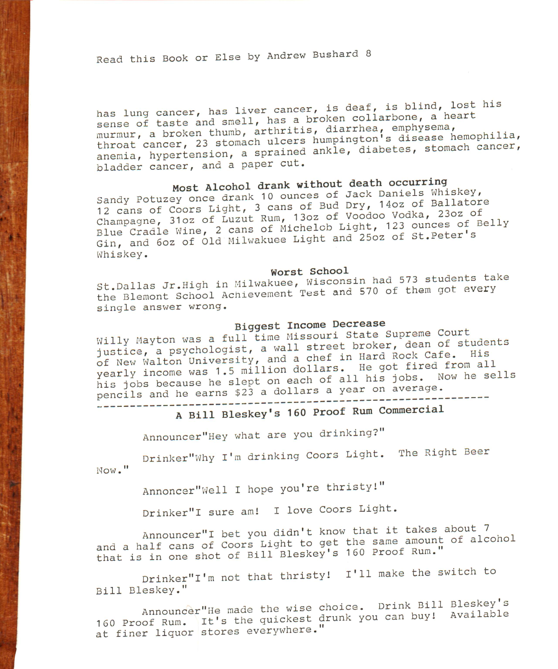

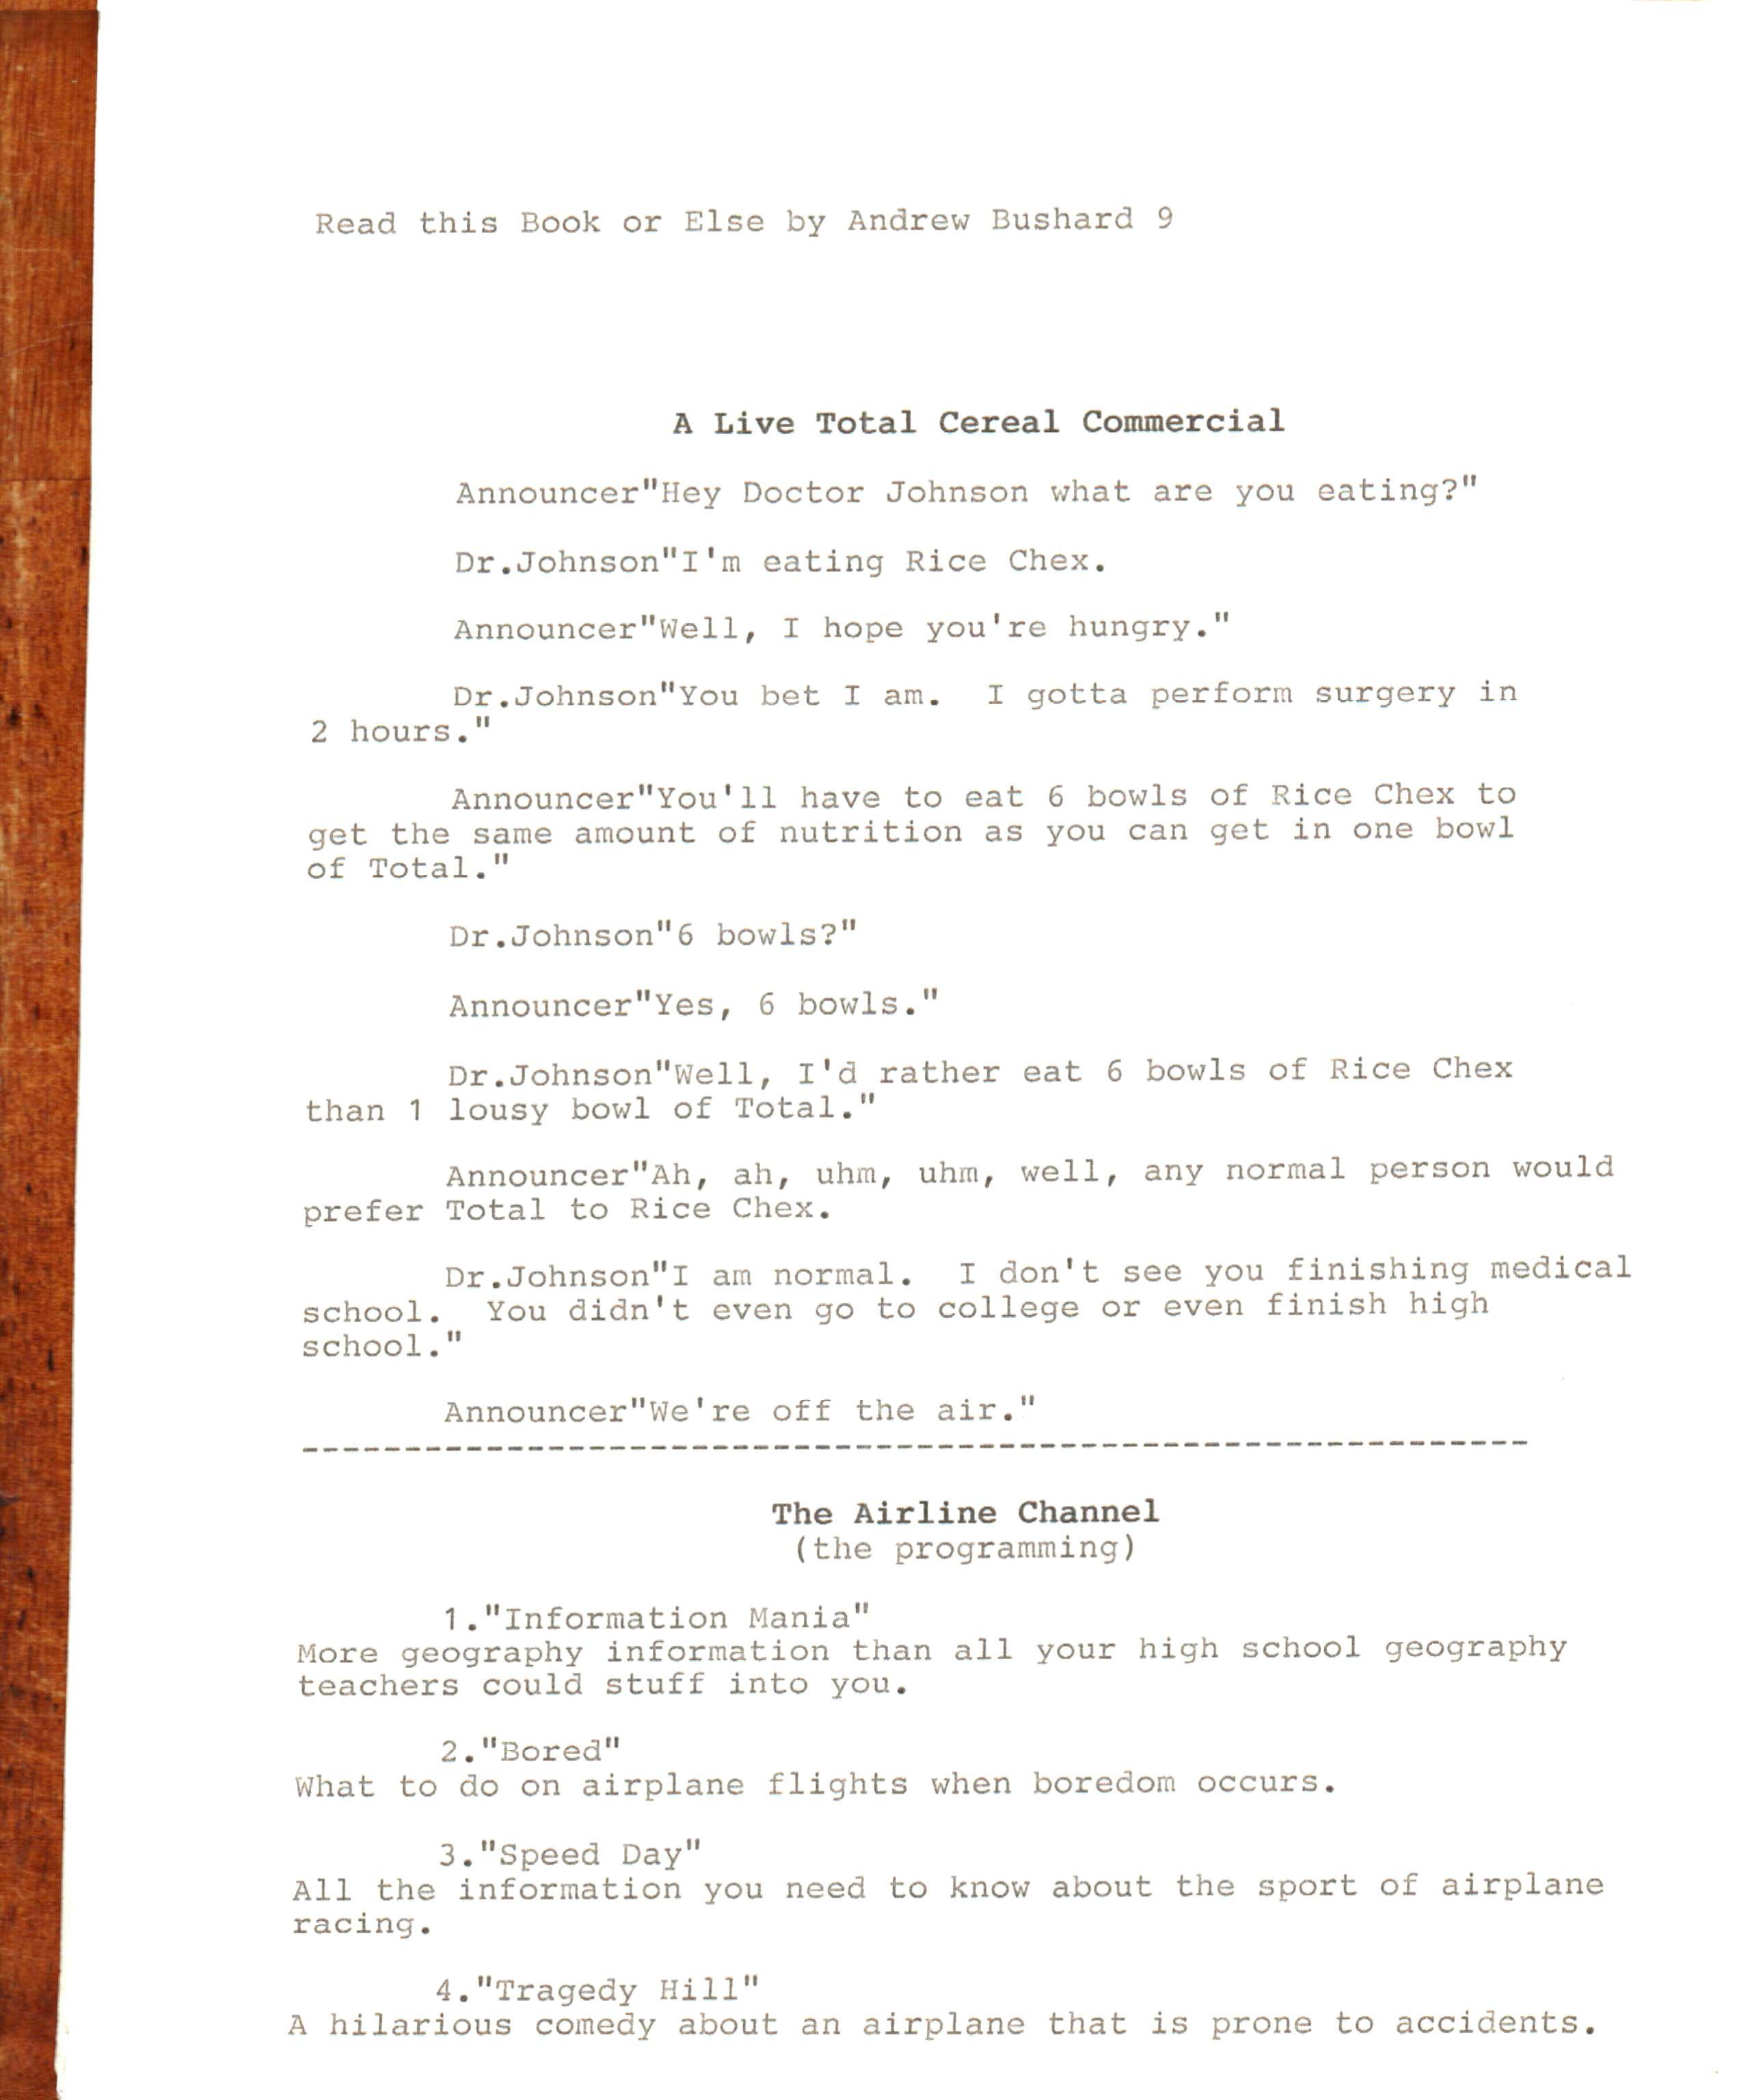

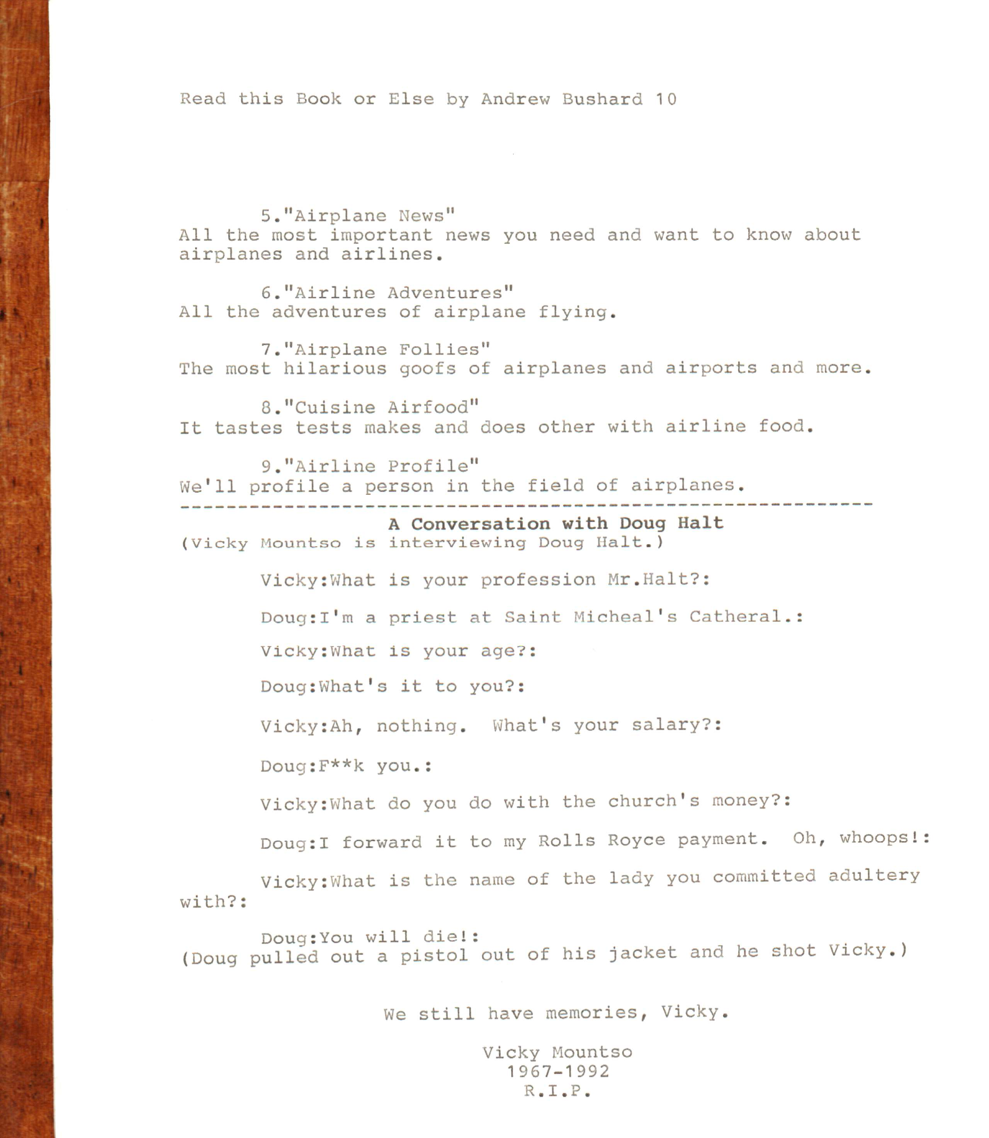

Read this Book or Else by Andrew Bushard 11

4 great years of journalism has come to an undeserved and premature end.

P.h.d. Lawrence Daleton's recipe to lose weight
Here is my recipe to lose weight:
Pour a 1602 cup of water,
put 1/2 a cup of sugar in it, then add 1/2 a cup of salt, then
add 6 tablespoons of vinegar, 1 tablespoon of Cinnamon, 8
tablespoons of vanilla, 3/4 cup of brown sugar, and 3 cups of
chili powder. Chill. If you drink 5 of these a day I guarantee
you will lose weight.

(Here is a pamphlet on an institution of higher learning)
St.Donald University
(A sampling of some courses available)
”Updated Psychology"
This class explores the human mind. Taught by the world's smartest felines.
“World Religions"
This class explores religions of the world such as Montreal, Egypt, Texas, Dallas, Africa, etc. Taught by Jim Hornt and
Louis Samed.
“Classical Poetry"
This class deals with classical poetry, the classical poets
and more.. Taught by great classical poets such as Shel Silverstein, Dr.Dre, Hammer, Ice T.. and others.

Read this hook or else by Andrew Bushard 12

James Down's Air Show
The exciting acts of the James Down Air Show:
2 planes fly straight towards each other in “in air.
A skydiver dives without a parachute or a net.
An airplane drops down one box of a billion dollars for the
audience to scramble for.
An airplane self destructs in mid air.
An airplane flies with a Person strapped to the wing.
An airplane is flown and crashed on the runway.
A stealth bomber bombs the audience.(have run scrambling from the bombs.)
a man will fly an airplane with half an engine.
An airplane is going to fly with human blood as fuel
There is going to be a special airplane that the audience will throw its complementary bombs at.
an airplane is going to touchdown in the audience area.
An airplane is going to fly 3 feet above the audience seating area in many circles around.
A pilot and two inexperienced fliers go in a plane :the plane flies real high. there is one parachute in it; the pilot parachutes out of the airplane and leaves the inexperienced people in the airplane alone.

Ride the Digusto

In an exposed cart you will ride through vomit, saliva, urine, feces, butter, manure, dirt, soap, ketchup, blood, cod liver oil, sweat, talcum powder, mucus, penicillin, diarrhea, tears, cough syrup, pile, digestive juices, dandruff, flour, sugar, mud, adrenaline, sodium, car wax, and pus.

Read this Look or Else by Andrew Bushard 13
The Tobacco Station
1 (the programming)
1."Joe Camel and Friends"
A terrific program for young viewers about the adventures of
Joe Camel, the hard Pack and other "smooth" characters.
2."Tobacco Champs"
Tobacco companies compete in various types of competitions.
3 Tobacco technology”
The latest developments in tobacco technology.
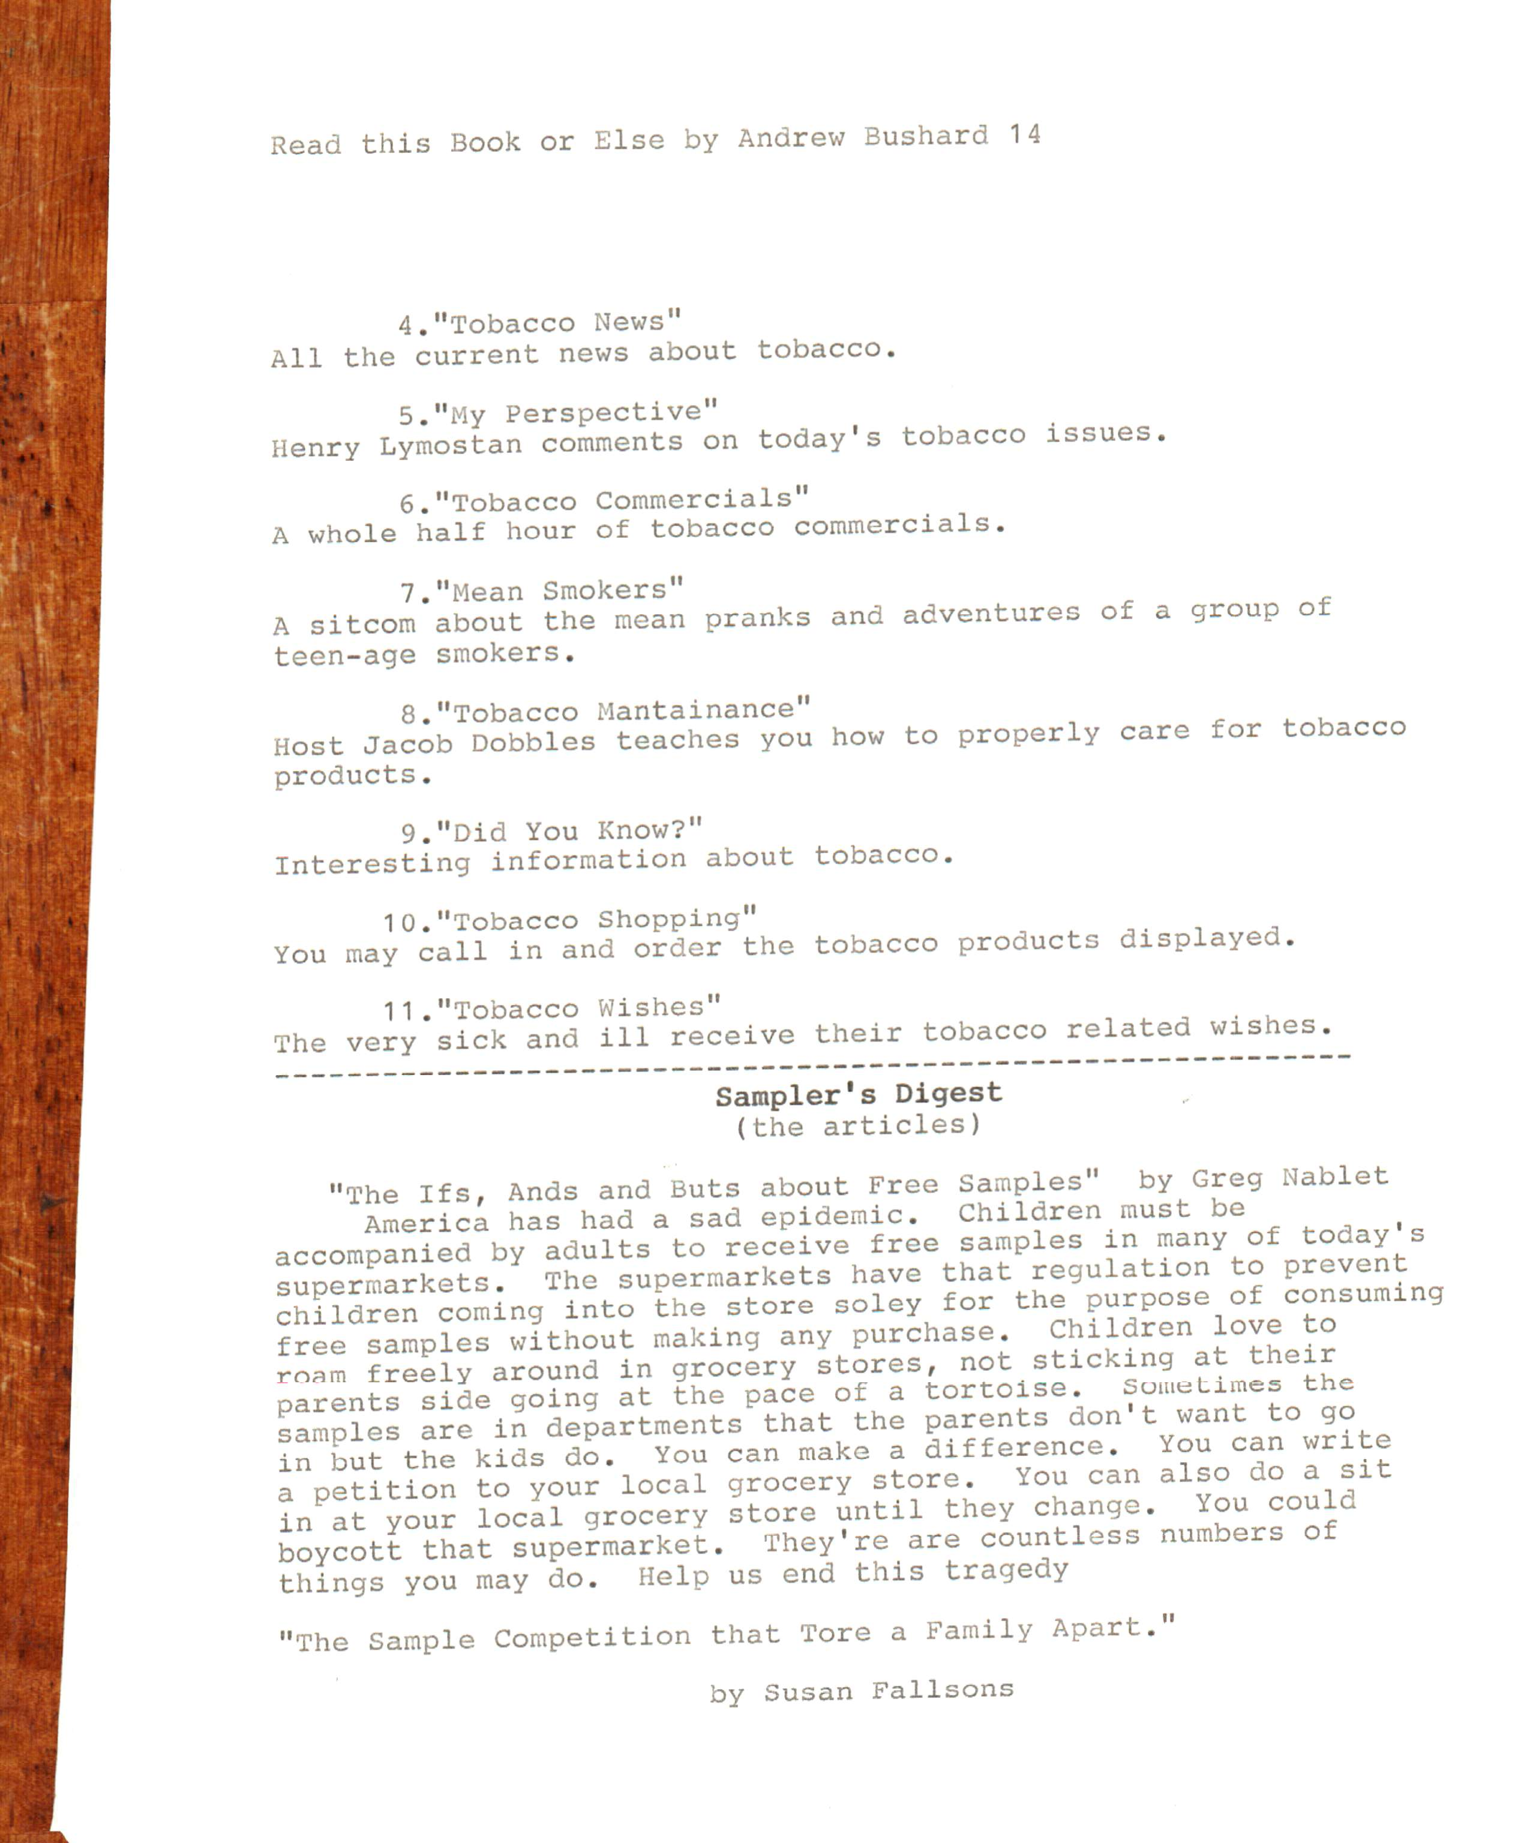

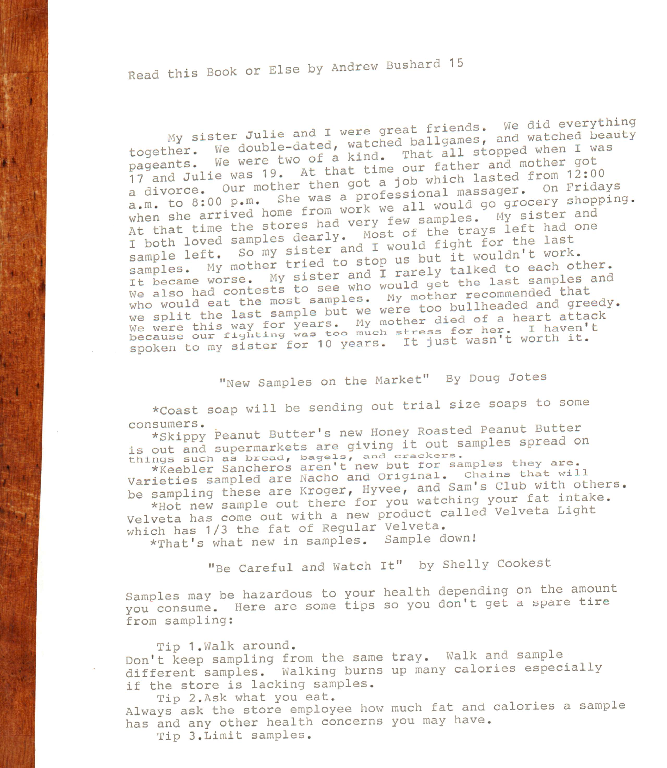

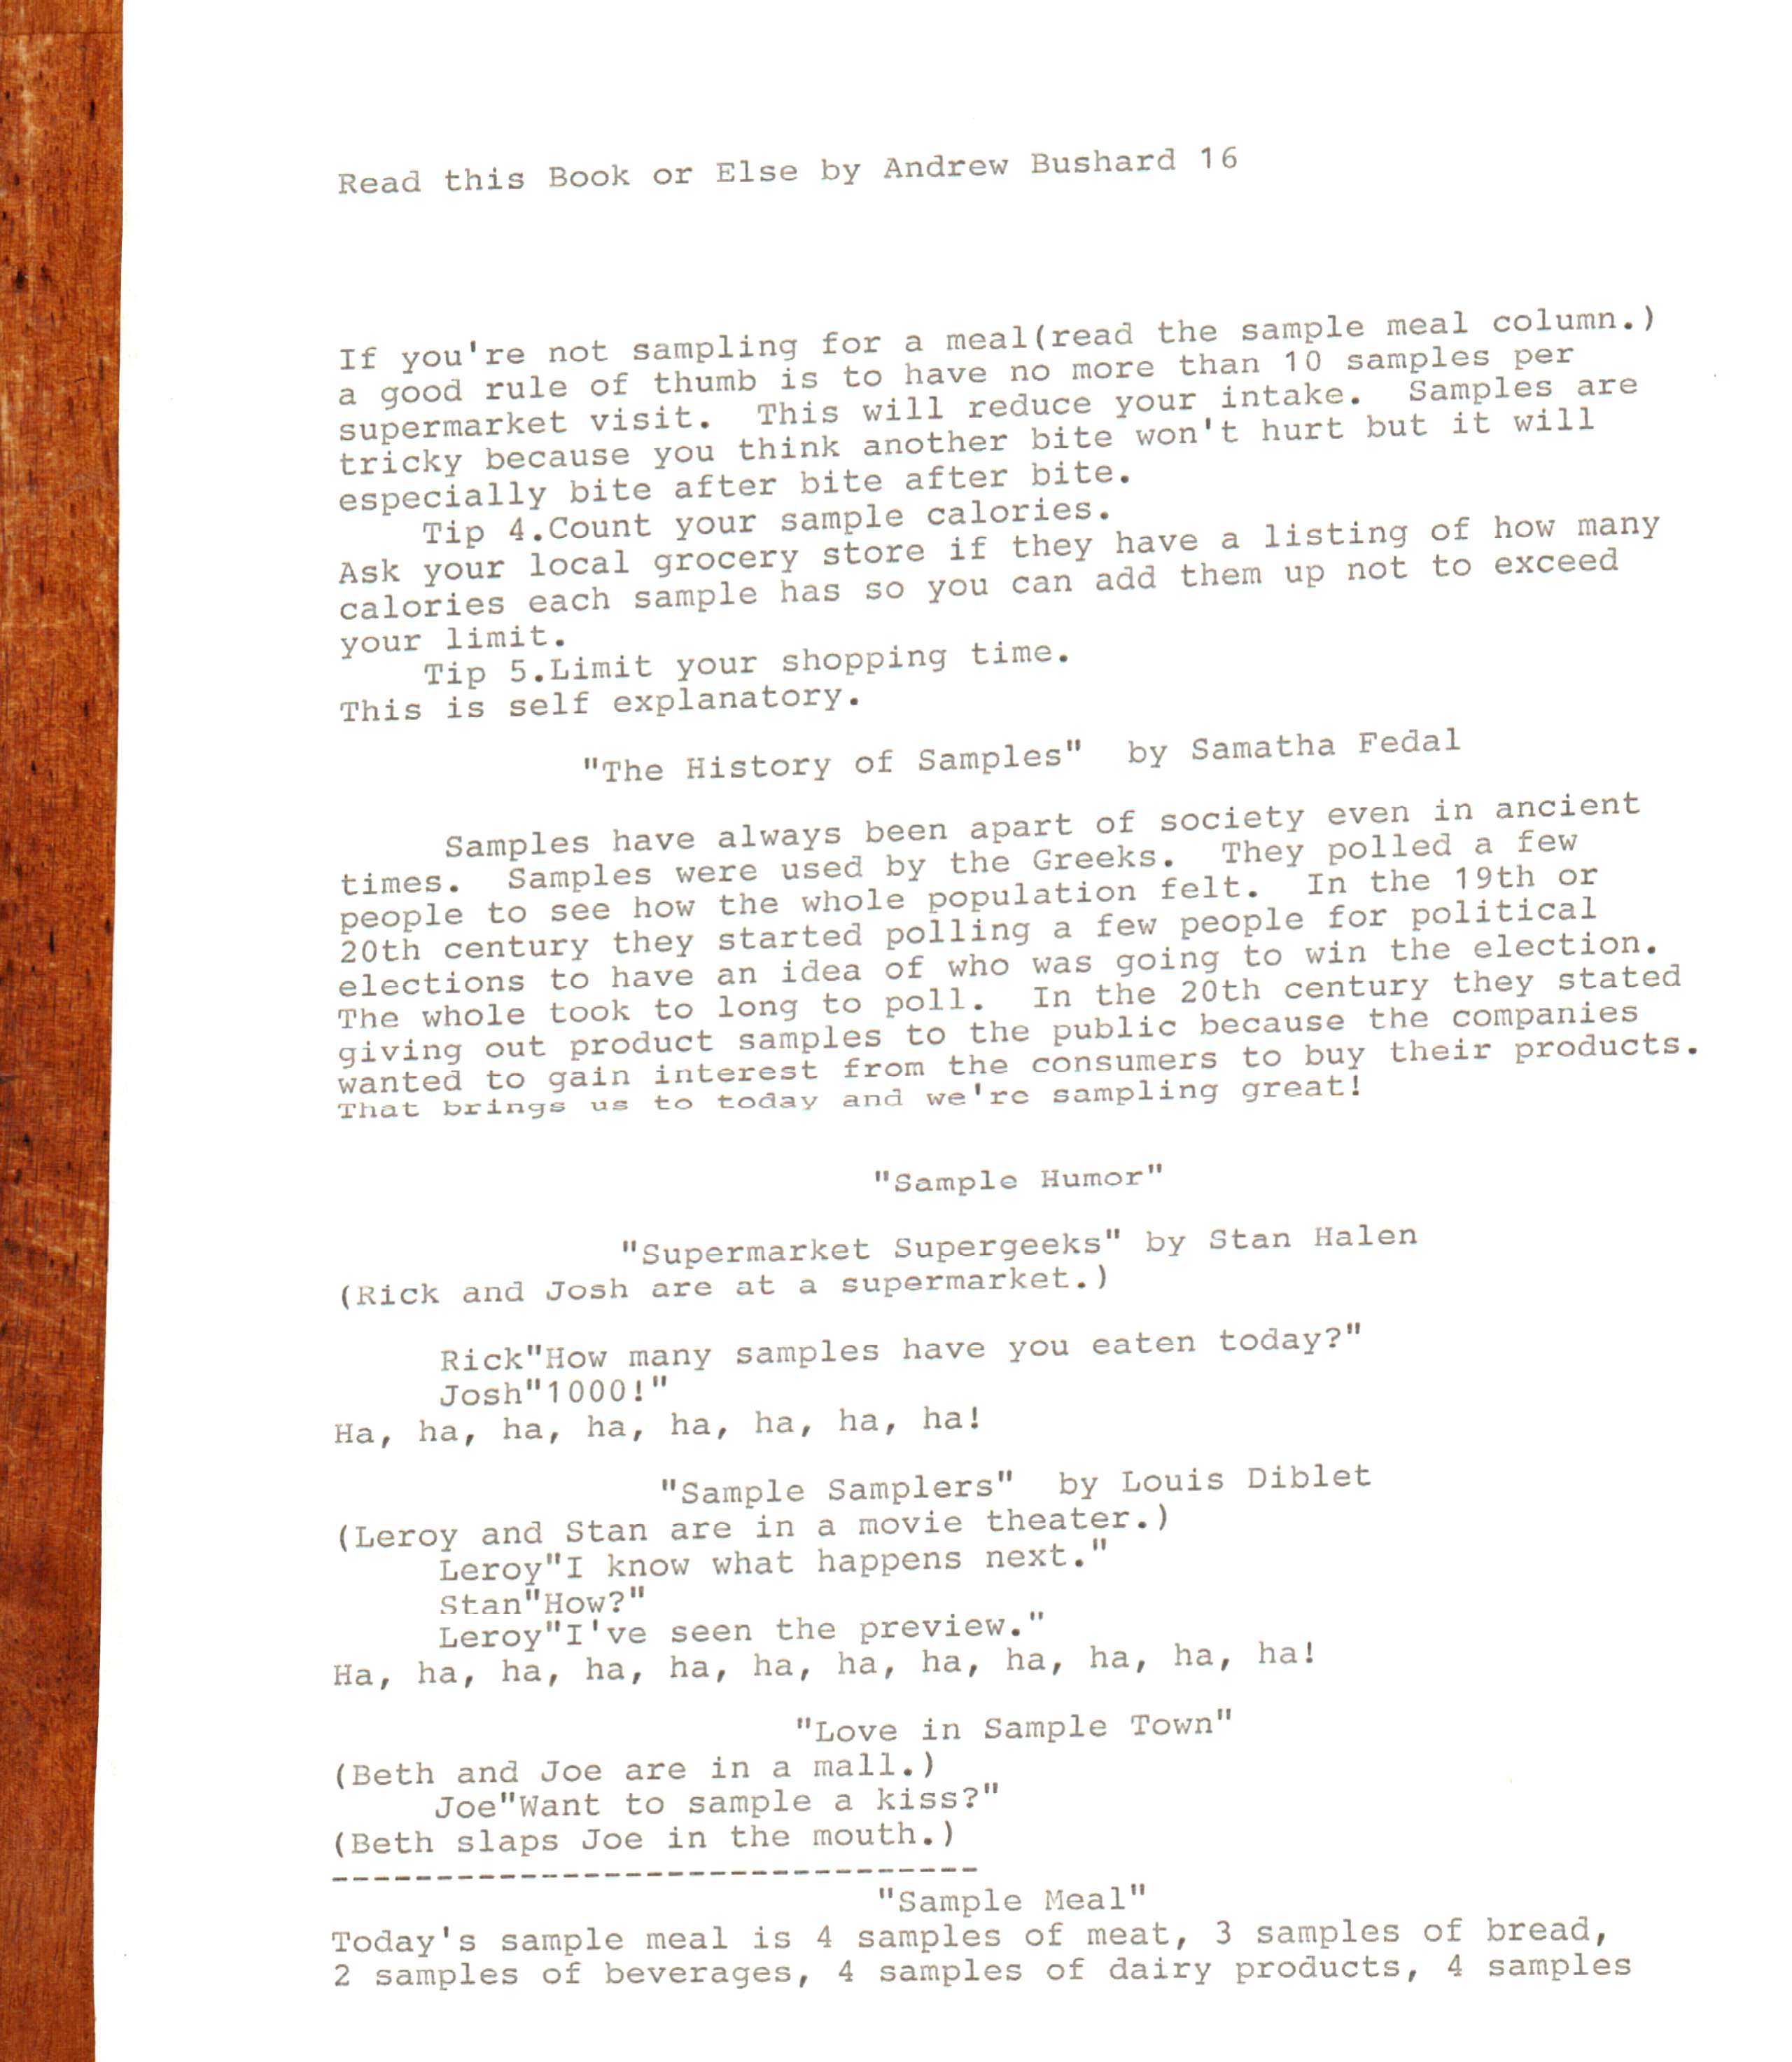

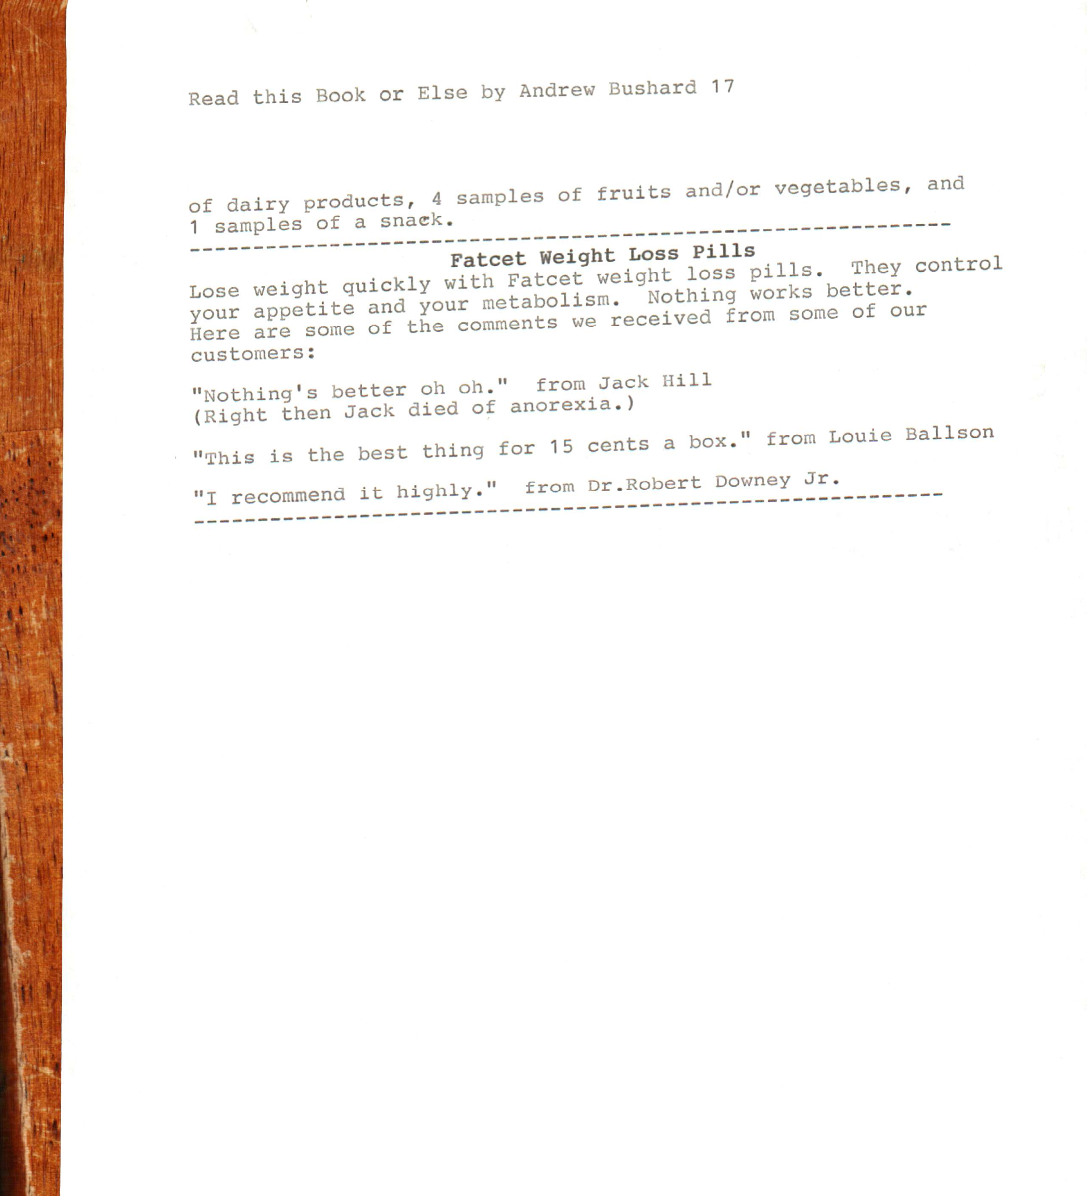

If Popular Slogans Were Changed and Always Read the Fine Print resemble similar Mad Magazine article types
Mr. Literal and Mr. Capet's joke about guerrilla warfare has appeared by other writers elsewhere
Mad Magazine devised specialty television channels, so this inspired me to create the Restroom Channel, the Weather Station, the Super Sewing Network, the Tobacco Channel, the Airline Channel, and the Religious Channel.
Mad Magazine joked about the USPS, so this inspired my entries about it in Predictions for 2016.
Mad Magazine made up universities, so this inspired me to create St. Donald University. Mad Magazine also had a joke similar to my entry for Classical Poetry.

