Mumia Abu Jamal Awareness Week
September 19-25.
Rally for a cause! 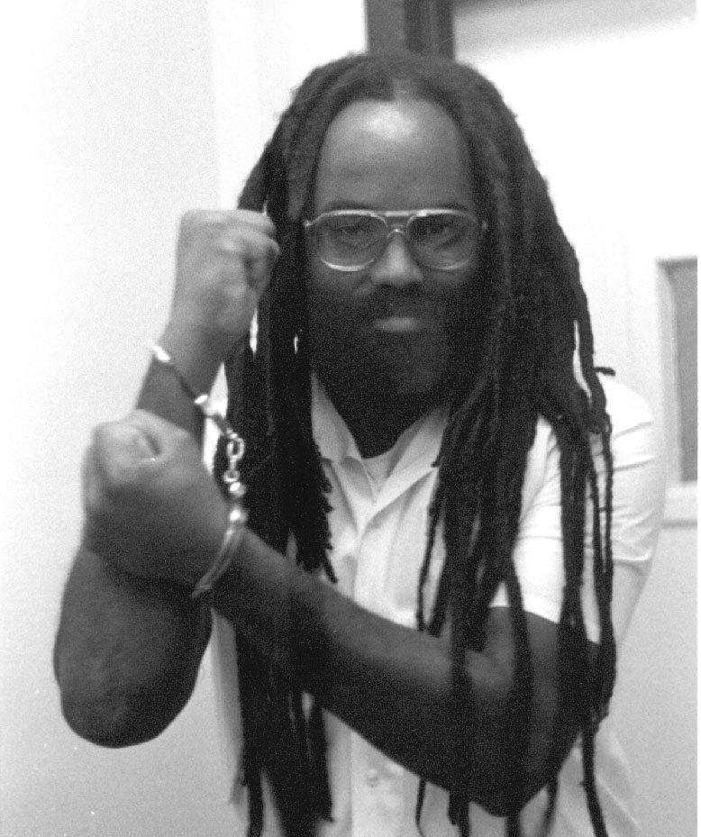
Participate in a jam-packed week!
This week we are going to do many things to spark consciousness and to fight the injustice of Mumia Abu Jamal's plight.

We are going to put on events which promote awareness of Mumia Abu Jamal and all the issues of his case.

- Sunday September 19th, 8:00 p.m.: Chalking and hanging of the Mumia banner. Political prisoner informal discussion. Nelson Hall room 308.

- Monday September 20th, 8:00 p.m.: Presentation of Mumia Abu Jamal's case and discussion afterwards. Nelson Hall room 308.

- Tuesday September 21st, 9:00 p.m.: Open Rally Anyone can speak words of support for Mumia. Nelson Hall room 308.

- Wednesday September 22nd, 8:00 p.m.: Playing of All Things Censored, Mumia's CD, and discussion. Nelson Hall room 308.

- Thursday September 23rd, 8:00 p.m.: Racism (institutional and societal) informal discussion. Nelson Hall room 308.

- Friday September 24th, 11:00 a.m.: Vigil for Mumia and Death Penalty in Nelson Hall room 308, 12:30 p.m.: Leafleting/ Demonstration in front of U.C., 1:30 p.m.: Mumia Street Theater in front of U.C.

For more information:

Please call Andrew Bushard
@341-5750 or email fedwittel@uwsp.edu

Sponsored by Federation Without Television

