Debate: The Proper Role of the Military in American Society

A pacifist view vs. a pro military view
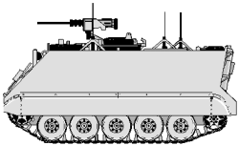
May 7th, 8:15 p.m., UW Stevens Point ‘s University Center Room 125A/B.

Guaranteed to be intellectually stimulating!

Sponsored by Federation Without Television

